**1. Set the variable test1 to the string 'This is a test of the emergency text system,' and save test1 to a file named test.txt.**

**Ans:** 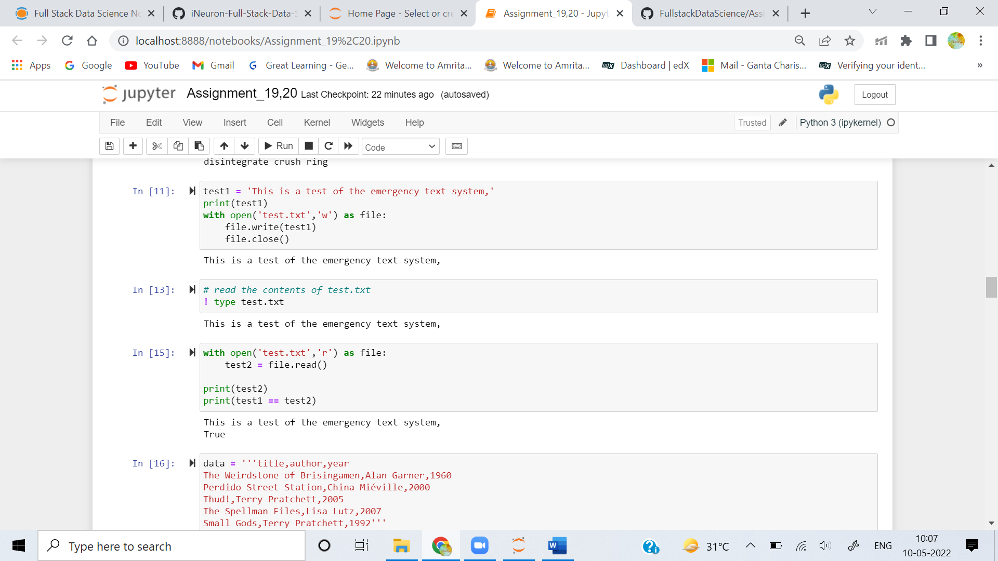

**2. Read the contents of the file test.txt into the variable test2. Is there a difference between test 1 and test 2?**

**Ans:**



**3. Create a CSV file called books.csv by using these lines:**

**title,author,year**

**The Weirdstone of Brisingamen,Alan Garner,1960**

**Perdido Street Station,China Miéville,2000**

**Thud!,Terry Pratchett,2005**

**The Spellman Files,Lisa Lutz,2007**

**Small Gods,Terry Pratchett,1992**

**Ans:**

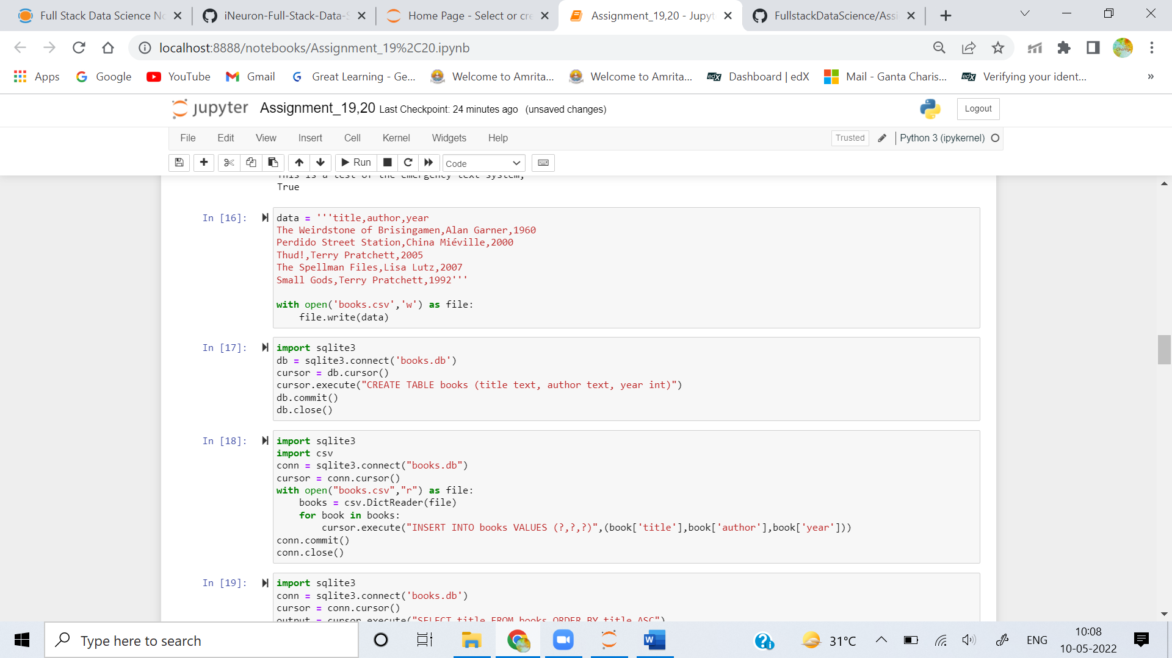

**4. Use the sqlite3 module to create a SQLite database called books.db, and a table called books with these fields: title (text), author (text), and year (integer).**

**Ans:** 

**5. Read books.csv and insert its data into the book table.**

**Ans:** 

**6. Select and print the title column from the book table in alphabetical order.**

**Ans:** 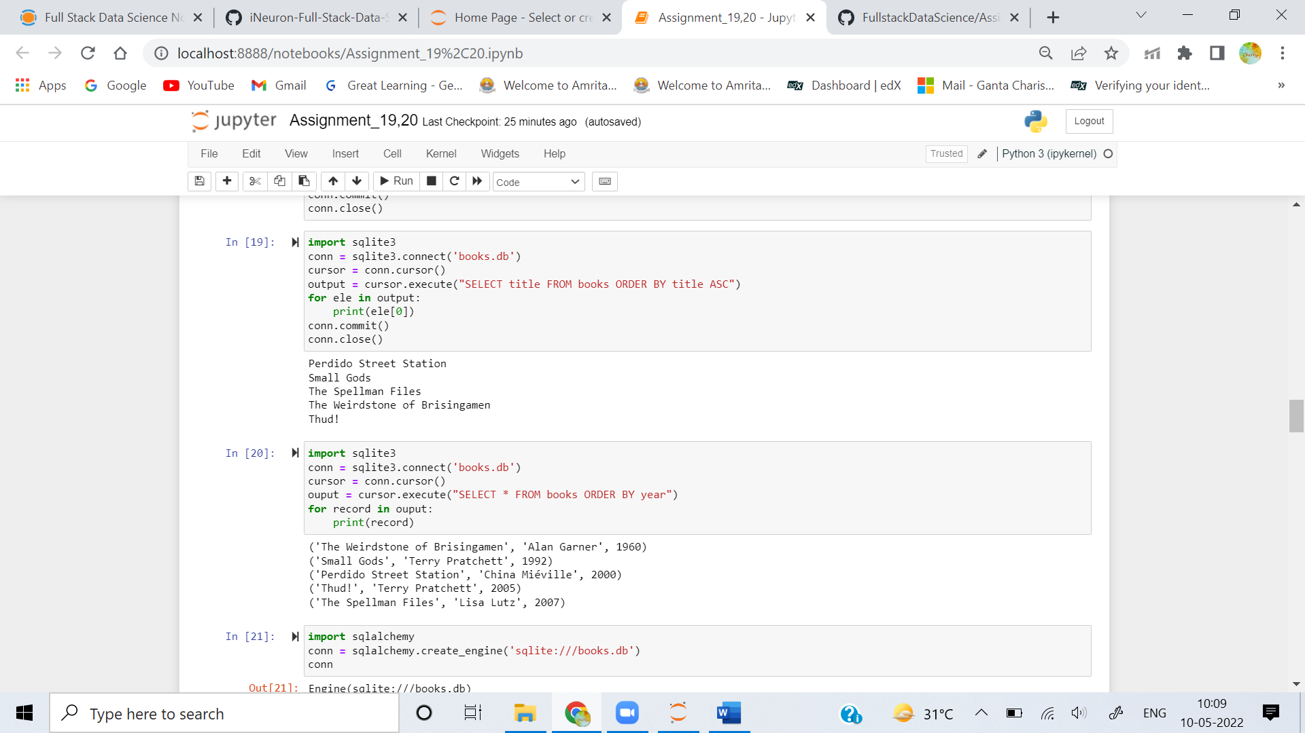

**7. From the book table, select and print all columns in the order of publication.**

**Ans:** 

**8. Use the sqlalchemy module to connect to the sqlite3 database books.db that you just made in exercise 6.**

**Ans:** 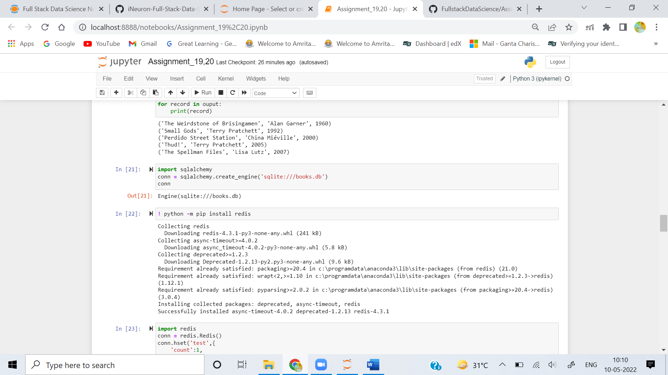

**9. Install the Redis server and the Python redis library (pip install redis) on your computer. Create a Redis hash called test with the fields count (1) and name ('Fester Bestertester'). Print all the fields for test.**

**Ans:**

**10. Increment the count field of test and print it.**

**Ans:**